**Design**

* + An object is a concept, abstraction or thing with well-defined boundaries and meaning for an application. Each object in a system has three characteristics: state (fields / variables in some languages), behaviour (methods), and identity.
  + A class is a description of a group of objects with:
    - common properties (attributes)
    - common behaviour (operations)
    - common relationships to other objects
    - common semantics

Dog - Class

Ralf - Dog / instance of class Dog

Ralf’s colour, weight and age - Fields

Class **>>>>>>>>>** **Defines** Fields an Object has

**V V**

**V** Instance **V** Values stored in object

**V** **V**

Object **>>>>>>>>>** Attributes (Values stored in fields)

**Naming Classes:**

* + should capture a single abstraction.
  + should be a singular **noun** that characterises the abstraction.
  + should be named using the   
    vocabulary of the domain.

* + Data stored = class fields
  + Actions = methods, usually **verbs**

**Coupling:**

* Coupling refers to links between separate units of a program. If two classes depend closely on many details of each other, they are said to be tightly coupled. Always aim for loose coupling.

**Cohesion:**

* Cohesion refers to the number and diversity of tasks that a single unit is responsible for. If each unit is responsible for one single logical task, it is said to have high cohesion. Cohesion applies to both classes and methods. Aim for high cohesion.
* A **method** should be responsible for one and **only one well defined task.**

**RDD (Responsibility-driven design):**

* Each class should be responsible for manipulating its own data.
* The class that owns the data should be responsible for processing it.
* When a change is needed, as few classes as possible should be affected.
* A method is too long if it does more than one logical task.
* A class is too complex if it represents more than one logical entity.

Control Structures:

Any algorithm can be designed used three control structures:

* Sequence.
* Selection.
* Repetition.

Example -

|  |  |
| --- | --- |
| Count people  Get drink order  Take out wallet | Sequence |
| If not enough money  borrow some  Else  take out money | Selection |
| Walk to the bar |  |
| While bar staff are busy  try to catch their attention | Repetition |
| Order drinks  Pay for drinks  Return to table |  |

Activity Diagrams:

Terminator (Also used for start)

Selection

Action box or module

* Activity diagrams have only one way in, and one way out.
* Selection boxes have one sequence line going in, and two lines coming out (one for true, and one for false).
* Action box / module has only one line in and one line out.
* Terminator box usually won’t have anything written in at the end (as is obviously the end).

Class Diagram relationships:

Based on UML (Unified modelling language)

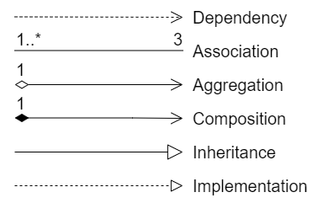

Below is based on orientation of above depictions.

* Dependency - “USES” “Know” relationship Short term use, Object on left uses object on right eg. object is used as a local variable within a method (not used for lifetime of object)
* Association - “USES” “Know” relationship. Long term use, object on left uses object on right. Association is not exclusive, objects can still exist without each other eg. object is used as an instance variable, state may be changed via a method. Can have 1 to many on both sides (diagram above shows this case has 1-many objects using 3 objects.).
* Aggregation - “Has-a” Ownership, weak type, instance variable
* Composition - “Has-a” Ownership, strong type, member object (right side) may NOT exist without the owner object (left side). Instance variable that’s usually created in constructor.
* Inheritance - “IS-A” relationship, Abstraction layers, get more abstract as you go up levels. Subclasses can only inherit from one superclass.
* Implementation - “CAN-DO” relationship, Abstraction layer, defines methods that class which implements it MUST have….doesn’t actually have method body, no constructors, but will say parameters methods have. Defined within an INTERFACE. A Class can implement many interfaces.

**Java**

* + Java is a high-level, class-based, object-oriented programming language that is designed to have as few implementation dependencies as possible.
  + It can be considered **both** a **compiled and an interpreted language** because its source code is first compiled into a binary byte-code. This byte-code runs on the Java Virtual Machine (JVM), which is usually a software-based interpreter.
  + IDE (Integrated Development Environment) - a visual program to help developer write Java Programs. This will USE the JDK.
  + JVM (Java Virtual Machine) - program that emulates (executes) Java byte-code that is the compiled form of java code.
  + JDK (Java Development Kit) - Software development kit. Contains everything you need to compile and run your java programs.
  + JRE (Java Runtime Environment) - software bundle that allows Java program to run.

Useful links:

* [docs.oracle.com/en/java/index.html](http://docs.oracle.com/en/java/index.html) Documentation
* [docs.oracle.com/javase/tutorial/](http://docs.oracle.com/javase/tutorial/) Tutorials
* [docs.oracle.com/javase/7/docs/api/](http://docs.oracle.com/javase/7/docs/api/) Java API (Application Programmers

Interface - description for all library classes) can also google search: “Java API

Oracle” for most up to date information.

* [w3schools.com](http://w3schools.com) Tutorials

Java Advantages:

* High level.
* Portable code.
* Object-oriented.
* Good library support.
* Relatively easy to debug.

Java Disadvantages:

* Not as fast as lower level languages such as C or C++.
* Requires Java Virtual Machine.
* Not suitable for system level code, such as device drivers.

Types of Comments:

Single Line Comment - //

Everything to the right is a comment.

Multiple Line Comments - /*……*/

Everything between the start and end markers is a comment.

Documentation Comments - /**……..*/

Everything in-between markers can be automatically documented.

Cannot have comments within comments.

Escape Sequences:

|  |  |
| --- | --- |
| Escape Sequence | Description |
| \t | Insert a tab in the text at this point |
| \b | Insert a backspace in the text at this point |
| \n | Insert a newline in the text at this point |
| \r | Insert a carriage return in the text at this point |
| \f | Insert a form feed in the text at this point |
| \' | Insert a single quote character in the text at this point |
| \" | Insert a double quote character in the text at this point |
| \\ | Insert a backslash character in the text at this point |

Structure of Classes:

// Imported packages can be added here

public class ClassName {

fields

constructors

methods

}

* Class names should start with a capital, then capitalise each new word.
* DO NOT start class name with a number, but may contain numbers.
* If using a symbol, only use underscore ( _ ).
* DO NOT use Java key words.

Visibility / Access Modifiers:

* + Private: they cannot be accessed by another class, only by the class they are in.
    - * + However, private variables can be accessed from another class as follows:

x = AnotherClass.getVariable1( );

* + Public: they can be accessed by another class.
  + Classes, methods, fields and packages (a group of classes) can be declared private or public.

Classes are typically public.

Methods are either public or private depending on if other classes need access – typically public

Constructors tend to be public, but can be private.

Fields (attributes) are typically private.

Fields:

* + Fields are one sort of variable.
  + They store values through the life of an object.
  + They are accessible throughout the class (Known as Global Variables).
  + Defined at the top of the class.

Local Variables:

* + Methods can include shorter-lived variables (local variables).
  + They are defined within the method.
  + They exist only as long as the method is being run.
  + They are only accessible from within the method.
  + DO NOT require a visibility modifier.

DO NOT use same name for a local and global variable.

Static Fields:

* Static fields (class variables) are common to all objects of the class.
* If one instance invokes a change on a static field, that will cause the field to be changed for all instances of the class.
* Fields, Methods and Classes can all be declared as static.
* Only one instance of a static field exists.
* Static fields are useful if the value of the field is common to all objects of the class.
* DO NOT use static fields unless you have good reason e.g. tax rate.
* Most common use is for constants.
* Static methods ARE NOT allowed to access any non-static method or field.
* If all methods of a class are static, then the class can be used without being initialised.
* Can call a methods by either:

className.methodName( ) - Static method call (does not require instantiating the class).

objectName.methodName( ) - Instance method call (can only be accessed from an instance of the class using the keyword “new”).

methodName( ) within the class.

Constants:

* Variables that do not change ever.
* Constants are declared in CAPITALS.
* Should ALWAYS be preceded by keyword ‘final’.

Keyword ‘final’:

* Once a final variable has been assigned it ALWAYS contains the same value.
* A final Variable can ONLY be initialised once either by an initialiser or an assignment statement. Does not need to be initialised at point of declaration (called a ‘blank final’ variable).
* A final Class CANNOT be subclassed or inherited from.
* A final Method CANNOT be overridden or hidden by subclasses.

Variable Names:

* DO NOT capitalise first letter, but capitalise first letter of each new word there after.
* No numbers are allowed at the start of a variable name, but they can be used after a letter.
* Only symbol that is allowed is underscore ( _ ).
* Cannot use Java key words such as int, char, class, public, if, while.

Fields must be declared with visibility modifier, type and variable name at beginning of class if global.

Local Variables should be declared at the beginning of the method used in WITHOUT the visibility modifier, but WITH type.

Remember to use “ ; “.

Example declaring global fields:

public class TicketMachine {

private int price;

private int balance;

private int total;

// Constructor and methods omitted

}

Variable declaration statements:

* Variable declaration can also include an initialiser that specifies an initial value:

int i = 0;

* Can also specify multiple variables at the same time separated by commas:

int i, j, k;

toString( ) method:

* Method of Object class which is used to provide a string representation of an object.
* When an object is passed to print statement, compiler internally calls method and returns a representation of object as classname@hexadecimal which is a pointer to objects physical location in memory.
* This method can be invoked in a class to override the Object class method and will return Class name with parameters given in method toString( ).
* This should be included in most classes.

@Override

public String toString() {

return “Class_name [field1=“ + field1 + “, field2=“ + field2 + “]”;

}

Inheritance:

* Superclasses are the parent class which will have common attributes. This saves duplication of code, keeps high cohesion and low coupling. It also allows for easier maintenance and the program is easier to modify.
* Subclasses are the child classes to superclasses. This is shown in BlueJ with an arrow with a large white head pointing from the subclass to the superclass. The subclass inherits all of the superclass attributes and any new attributes unique to the subclass will be defined within the subclass.
* Keyword ‘extends’ followed by the superclass name will create a subclass. Position this information immediately after the subclass name.
* Keyword ‘super( )’ calls superclass constructor from the subclass. This is REQUIRED in all subclasses and MUST be first statement. Without one, the compiler inserts one without parameters. This will only work if the superclass constructor takes no parameters.

public class SubclassName extends SuperclassName {

unique fields to subclass defined here

…

Subclass constructor(with types and parameters) {

super(variables to be initialised in superclass constructor);

// subclass constructors must ALWAYS call ‘super’

// without one, compiler inserts one WITHOUT PARAMETERS

// this must be FIRST statement in subclass constructor

other fields to be initialised here in subclass;

}

Primitive Types:

* char - A single character, contained in single quotes. Can also store escape characters - memory 16 bits.
* boolean - true or false (non capitalised) - memory 1 bit.
* int - Integer numbers (whole numbers, no decimal point). Any value from -2147483648 to 2147483647 - memory 32 bits.
* float - Floating point numbers (real numbers with decimal point). Value must be followed by ‘f’ or will be interpreted as a double. Use instead of double if you need to save memory in large arrays of floating point numbers. NEVER use for precise values, such as currency. For that, you will need to use the [java.math.BigDecimal](https://docs.oracle.com/javase/8/docs/api/java/math/BigDecimal.html) class instead - memory 32 bits.
* double - Can store floating point numbers more precisely than a float, uses twice the storage to hold more decimal places. As with float, never use for precise values, such as currency - memory 64 bits.
* byte - An 8-bit signed two's complement integer. It has a minimum value of -128 and a maximum value of 127 (inclusive). Can be useful for saving memory in large arrays, where the memory savings actually matters. They can also be used in place of int where their limits help to clarify your code; the fact that a variable's range is limited can serve as a form of documentation - memory 8 bits.
* short - A 16-bit signed two's complement integer. It has a minimum value of -32,768 and a maximum value of 32,767 (inclusive). Can use a short to save memory in large arrays, in situations where the memory savings actually matters - memory 16 bits.
* long - A 64-bit two's complement integer. The signed long has a minimum value of -263 and a maximum value of 263-1. Use this data type when you need a range of values wider than those provided by int - memory 64 bits.

Strings:

* Strings are not a primitive type in Java.
* Must be in quotes, can be either double or single quotes.
* Interpreted as an object in Java.
* Type String must have capital ’S’.
* Operator ‘+’ will combine (concatenate) strings.
* Assignment operator ‘+=‘ is evaluated right to left AND REASSIGNS variable

String str = ‘Hello ‘;

int a = 3;

int b = 5;

System.out.println(str + a + b); // prints Hello 35

System.out.println(str); // prints Hello….unchanged by print statement above

System.out.println( str += a + b); // prints Hello 8

System.out.println(str); // prints Hello 8…….variable str has been changed

Structure of Methods:

visibility_modifier return_type method_name (parameter_type list_of_parameters){

/* declaration of local variables including type*/

/* Java code */

}

* If a method has nothing to return, then the return type should be void.
* Method Names should NOT start with a capital, but after the first word, each new word should be capitalised. DO NOT start with a number. If using symbols, ONLY use underscore ( _ ). DO NOT use Java key words.
* Structure consists of method header (defines methods signature, ie. visibility modifier, type and method name), and method body (encloses the method’s statements).

Return statements are used to return values from a method.

return 5;

return a;

return a * b;

return;

Can only return type defined before method_name.

The main method( ):

public static void main(String[] args) {

/*Java code*/;

}

* A special static method, MUST be static.
* Used as a starting point for programs.
* Required in every program.
* MUST be public.
* MUST be void and returns nothing.
* MUST be called ‘main’.
* Accepts a single argument of type String.
* Commonly contains a director method responsible for initiating and running other methods.

Constructors:

* Similar to methods in format, but USE CLASS NAME (including capitals).
* Have NO return type.
* Called when an object of the class is created.
* Used to initialise objects (and store initial values into the fields).
* Often receive external parameter values.
* Called when keyword ‘new’ is used followed by class name, e.g.;

objectType variableName = new ClassName( );

* Can have more than one constructor in a class, as long as the parameter list is different in each one.

Accessor Methods:

* Methods used to obtain information about an object are known as accessor methods.
* Commonly used to return / get the value of a private field.

public int getPrice() {

return price;

}

Mutator Methods:

* Used to mutate (i.e. change) an object’s state.
* Achieved through changing the value of one or more fields.
  + - Typically contain assignment statements.
    - Typically receive parameters.
* Commonly used to set the value of a private field.

public void insertMoney(int amount) {

balance = balance + amount;

}

Built in Methods:

substring( ) method:

* stringName.substring(index value slice from, index value slice to);
* index values start at 0.

equals( ) method:

* stringName1.equals(stringName2);
* Tests if two strings are the same.

toUpperCase( ) method:

* stringName.toUpperCase( );
* Converts every character of String to upper case.

contains( ) method:

* stringName.contains(“string_to_search_for”)

Character.toUpperCase( ) method:

* Enter char to be converted in parenthesis.
* Converts char entered to uppercase.
* Must assign to new variable to save change

toLowerCase( ) method:

* stringName.toLowerCase( );
* Converts every character to lower case.

length( ) method:

* stringName.length( );
* Returns number of characters, note this is different from index.

Parsing (Type Casting):

* char(int) to int - Character.getNumericValue(char);
* char to String - Character.toString(char);
* String to int - Integer.parseInt(String);
* get char from String - variable.charAt(index);
* int to String - String.valueOf(int); Also: Integer.toString(int);
* String to double – Double.parseDouble(String);

Assignment Statements:

* Values are stored into fields (and other variables) via assignment statements:

variable = expression;

“ = “ is called the assignment operator. This SETS the left value to equal the right value. This is different to equality operator “ == “ which CHECKS left value is equal to the right value.

* A variable stores a single value, so any previous value is lost.

Equality and Relational Operators:

|  |  |
| --- | --- |
| Operator | Description |
| == | Equal to  **NOTE -** does not work on Strings.  Be careful of using to compare objects as will  only compare the object **REFERENCE** |
| != | Not equal to |
| > | Greater than |
| >= | Greater than or equal to |
| < | Less than |
| <= | Less than or equal to |

Arithmetic Operators:

|  |  |
| --- | --- |
| Operator | Description |
| + | Additive operator (also used for String concatenation) |
| - | Subtraction operator |
| * | Multiplication operator |
| / | Division operator |
| % | Remainder operator |

Unary Operators:

|  |  |
| --- | --- |
| Operator | Description |
| + | Unary plus operator; indicates positive value (numbers are positive without this, however) |
| - | Unary minus operator; negates an expression |
| ++ | Increment operator; increments a value by 1 |
| -- | Decrement operator; decrements a value by 1 |
| ! | Logical complement operator; inverts the value of a boolean |

All statements below subtract 1 from value ‘a’.

a = a – 1;

a -= 1;

a—;

All statements below add 1 to value ‘a’.

a = a + 1;

a += 1;

a++;

++a;

NOTE - if used in a print statement (or other operation),

e.g. System.out.print(a++);

++a will add one BEFORE printing value

a++ will print THEN add one.

int a = 3;

System.out.println(++a); // Prints 4, a = 4 after print statement

int a = 3;

System.out.println(a++); // Prints 3, a = 4 after print statement

Operator Precedence:

| Operators | Precedence |
| --- | --- |
| postfix | expr++ expr-- |
| unary | ++expr --expr +expr -expr ~ ! |
| multiplicative | * / % |
| additive | + - |
| shift | << >> >>> |
| relational | < > <= >= instanceof |
| equality | == != |
| bitwise AND | & |
| bitwise exclusive OR | ^ |
| bitwise inclusive OR | | |
| logical AND | && |
| logical OR | || |
| ternary | ? : |
| assignment | = += -= *= /= %= &= ^= |= <<= >>= >>>= |

Print Statements:

System.out.println(“Print this.”);

* Will print text enclosed in quotes WITH line break.

System.out.print(“Print something else”);

* Will print text enclosed in quotes WITHOUT line break.

System.out.print( );

* Prints a newline.

System.out.print(‘\UC003’);

* Clears console window.
* cmd K / ctrl K clears console window in BlueJ.
* System must have capital “S”.
* Don’t forget “ ; “ or quotes.

if….else Statements:

if (expression1) {

statement1; // This block is executed when expression1 is true

statement2;

} else if (expression2) {

statement1; // This block is executed when expression1 is false

statement2; // Could also use if within an else branch, but this is

// preferable as more legible

} else {

statement1; // This block is executed when both expressions are

statement2; // false

}

* Good practice to indent statements and align parentheses.
* Start brackets on same line as statement, align closing bracket with beginning of statement. If next statement is connected (such as if…else, do…while, try…catch…finally etc.) then start statement on same line as closing bracket.
* { } only required when more than one statement present, but better to always use them.
* Note that the else will be associated with the nearest if statement…important if brackets are not used on single statement if loops.
* else statement is optional.
* else if …else as above is preferable to else within an if loop within an else loop for readability.
* Remember to use “ ; “.

break statement:

* break allows a premature exit from within the body of the loop which stops execution of more code and further case testing inside the block.
* Passes control to the first statement after the loop.

continue statement:

* + Opposite of break.
  + Control goes immediately back to the start of the loop.

switch Statement:

* Equivalent to a whole load of if….else statements, but a list of cases to run when true.

switch (expression) {

case constExpression: statement(s);

break;

case constExpression: statement(s);

break;

...

default: statement(s);

break;

}

* Good practice to indent statements and align parentheses.
* Start brackets on same line as statement, align closing bracket with beginning of statement. If next statement is connected (such as if…else, do…while, try…catch…finally etc.) then start statement on same line as closing bracket.
* default: is OPTIONAL.
* Remember “ : “ and “ ; “.
* default is run if there is no case match.

while loop:

counter_initialise_statement;

while (expression) {

statement1;

statement2;

counter_change_statement;

}

* While loops only do the statement while the expression is true. Because the expression is checked first, this means the statement may not be run at all (if expression is false the program moves out of the loop).
* If the expression is true, it will stay in the loop and the statement is executed again.
* { } only required when more than one statement present, but better to always use them.
* Good practice to indent statements and align parentheses.
* Start brackets on same line as statement, align closing bracket with beginning of statement. If next statement is connected (such as if…else, do…while, try…catch…finally etc.) then start statement on same line as closing bracket.
* Remember to use “ ; “.
* Initialise counter before entering loop, and change counter inside loop so loop will eventually exit.

do…..while loop:

counter_initialise_statement;

do {

statement1;

statement2;

counter_change_statement;

} while (expression);

* This type of loop always does the statement at least once as the statement is carried out first and then the expression is checked.
* If the expression is false, the program will move out of the loop.
* If the expression is true, it will stay in the loop and the statement is executed again.
* { } only required when more than one statement present, but better to always use them.
* Good practice to indent statements and align parentheses.
* Start brackets on same line as statement, align closing bracket with beginning of statement. If next statement is connected (such as if…else, do…while, try…catch…finally etc.) then start statement on same line as closing bracket.
* Remember to use “ ; “.
* Initialise counter before entering loop, and change counter inside loop so loop will eventually exit.

for loop:

for (counter_initialisation; condition; counter_increment) {

statement1;

statement2;

}

* A for loop allows ‘loop counter initialisation’ and ‘loop counter change’ as part of the control structure.
* Note the semi-colons between statements in the parentheses.
* { } only required when more than one statement present, but better to always use them.
* Good practice to indent statements and align parentheses.
* Start brackets on same line as statement, align closing bracket with beginning of statement. If next statement is connected (such as if…else, do…while, try…catch…finally etc.) then start statement on same line as closing bracket.
* Remember to use “ ; “.

Nested control structures:

for ( ; ; ) {

if ( ) {

do {

} while( );

} else {

for ( ; ; ) {

}

}

}

* It is possible to ‘nest’ loops, selection and sequences to any depth.
* Note the need for indentation and alignment of brackets.
* Start brackets on same line as statement, align closing bracket with beginning of statement. If next statement is connected (such as if…else, do…while, try…catch…finally etc.) then start statement on same line as closing bracket.

Packages:

* Java API is a library of prewritten classes included in the Java Development Environment.
* Some packages require importing before they can be used. (see useful links above for API documentation)

import package.name.ClassName;

* Packages can be imported individually, which helps to reduce file size, memory usage and load times:

import java.util.PackageName;

* Packages can also be imported as a whole (note the “ . “ before the “ * “):

import java.util.*;

* “package” is a keyword in Java and can be used to create custom packages similar to creating a class.

Arrays:

* + An ORDERED collection of objects or primitive types.
  + Can only store the object type which is the same as the type which was declared when array is created, i.e. cannot mix object types in an array.
  + Access values with an index number.
  + 1st element has index 0, last element will be 1 less than length.
  + Arrays have a fixed number of elements or slots which is defined when initialised (size). See ArrayList class (below) for dynamic arrays which do not require a fixed number of elements.

Defining and creating an array:

type[] arrayName;

arrayName = new type[size]

* size is number of empty slots in an array.
* Its good practice to use constants (with final keyword and declared in capitals) to define array sizes and assign this to a variable which is passed to the array when creating it.
* Use visibility modifiers if declaring as a global field, same as other objects.
* Note there is no spaces between type and the square brackets.

Populate an array with a for loop:

type[] arrayName = new type[size];

for(int i = 0; i < arrayName.length; i++) {

arrayName[i] = new type();

}

Changing a value within an array:

arrayName[indexToSet] = newValue;

* Note arrayName is in front of brackets when referencing the array or changing element values.
* It is after when declaring and type is before.

Return length of an array:

arrayName.length;

Specify values in an array when its declared:

private type[] arrayName = {value1, value2….};

* Note CURLY brackets are used when setting values separated with a comma.

Printing an array:

* A single element can be printed as follows:

System.out.println(arrayName[element_index]);

* You CANNOT print a full array in this way, as only a reference to the array is passed to the print statement.
* To print a full array, must use a for loop.

type[] arrayName = {ele1, ele2…};

for(int i = 0; i < arrayName.length; i++) {

System.out.println(arrayName[i]);

}

* There is also a specific for loop, exclusively for arrays and ArrayList class, (collections). “foreach” loop:

type[] arrayName = {ele1, ele2…};

for(type i : arrayName) {

System.out.println(i);

}

* type within the for statement, must be the same type as the array.
* Note a colon is used in the for loop.
* Read the colon as “in”, as above would be “foreach i element in arrayName”.

Multidimensional arrays:

type[][] arrayName = { {array1ele1, array1ele2…}, {array2ele…}, {array3ele….} };

* This will create a 2D array.
* Note a 2D array can have more than 2 arrays (a 2D drawing can have more than 2 lines), but each must contain the same number of elements.
* Each array must be separated by a comma.

Accessing a multidimensional array:

arrayName[1][2];

* This will access array2ele3.
* 1st index value is in reference to the outermost arrays, 2nd is elements within that array (or further arrays if 3D or greater arrays).

Process all elements in a multidimensional array:

type row, column;

for(row = 0; row < arrayName.length; row++) {

for(column = 0; column < arrayName.length; column++) {

System.out.println(arrayName[row][column]);

}

}

ArrayList class:

* ArrayList are an implementation class in Java collections framework.
* ORDERED collection.
* A resizable Array found in the Java.util package.
* Unlike built-in arrays, ArrayList allows you to add and remove elements at will without having to create a new array each time.
* ArrayLists CAN be printed as a whole object.
* Must import the package first.
* CANNOT hold primitive types. This is because ArrayLists hold an object reference rather than a value types. Must use BOXED TYPES (wrapper classes which wrap primitive types such as int and create equivalent objects such as Integer).

Import and create an ArrayList:

import java.util.ArrayList;

ArrayList<type> arrayListName = new ArrayList<>();

* Note different syntax and < >.
* Can also be used within a class constructor, and hence it’ll be of that class type. This means the line ArrayList<type> can be omitted.

Add , remove and modifying methods for ArrayList class:

arrayListName.add(eleToAdd); // Adds an element

arrayListName.remove(eleToRemove); // Removes an element

arrayListName.get(ele_index); // Returns element at index value (0 is 1st)

arrayListName.set(index, new_ele); // Changes element at index to new_ele

arrayListName.clear(); // Removes all elements

arrayListName.size(); // Returns number of elements

Collections package:

* A useful package used to sort arrays.

<https://docs.oracle.com/javase/8/docs/technotes/guides/collections/overview.html>

import java.util.Collections;

Collections.sort(arrayListName);

OR:

Arrays.sort(arrayName);

Iterators:

* Iterators are a function in Java collections framework.
* An object used to loop through collections such as ArrayList and HashSet.
* Must import package first.
* Code below will create an iterator object:

import java.util.Iterator;

Iterator<type> it = collectionName.iterator();

* Below will print out each element in turn.

while (it.hasNext()) {

System.out.println(it.next());

}

* Iterators like arrays, CANNOT be printed out as only a reference is passed.
* Can be used to modify a selection of elements as follows:

while (it.hasNext()) {

Integer i = it.next();

if (i < 10) {

it.remove();

}

}

* The above will remove elements with values of less than 10.
* Note iterator methods next( ) and hasNext( ).

LinkedLists:

* LinkedLists implements Queue / Deque (First-In-First-Out FIFO) and Stacks (push pop, First-In-Last-Out (FILO)).

LinkedList<type> linkedListName = new LinkedList<>();

* Methods are similar to ArrayLists.

HashMaps:

* HashMaps are an implementation class in Java collections framework.
* Consists of pair values “keys” and “values”.
* “Keys” must be all of the same type, but can be different to the type of the “values”. This is the same for “values”.
* CANNOT hold primitive types. This is because HashMaps hold an object reference rather than a value types. Must use BOXED TYPES (wrapper classes which wrap primitive types such as int and create equivalent objects such as Integer).
* Must import package first.
* Code below will create an HashMap object:

import java.util.HashMap;

HashMap<KeyType, ValueType> hashMapName = new HashMap();

Modifying methods for HashMaps:

hashMapName.put(key, value); // Adds an item to HashMap

hashMapName.get(key); // Returns value of key-value pair

hashMapName.remove(key); // Removes key-value pair

hashMapName.clear(); // Removes all key-value pairs

hashMapName.size(); // Returns number of key-value pairs

Loop through a HashMap:

* Note both methods below will require HashMap to have been initialised declaring types (as above) or it will not work.
* Prints all keys:

for (type i : hashMapName.keySet()) {

System.out.println(i);

}

* Prints all values:

for (type i : hashMapName.values()) {

System.out.println(i);

}

HashSet:

* HashSet is a collection of items where every item is unique, found in java.util package.

HashSet<Type> hashSetName = new HashSet<>();

Random Numbers:

* Library class “Random” can be used to generate random numbers:

import java.util.Random;

Random generatorName = new Random();

generatorName.nextInt(6); // Generates a random “int” between 0 and 5

// Can also be nextFloat() or nextDouble()

// even nextBoolean()

Scanner Class:

Import package:

import java.util.Scanner;

* Required package to use Scanner class.

Create object:

* Once imported, we can create Scanner objects.

// Creates an object of Scanner called “input”

// The “System.in" parameter is used to initialise object with predefined

// standard input object

// It works just like taking inputs from the keyboard

Scanner input = new Scanner(System.in);

// Creates an object of Scanner called “sc1”

// read input from the input stream

Scanner sc1 = new Scanner(InputStream input);

// read input from a File called file (properties can be set at different point)

Scanner sc2 = new Scanner(File file);

// read input from a string str

Scanner sc3 = new Scanner(String str);

* Here, we have created objects of the Scanner class that will read input from the standard input, input from [InputStream](https://www.programiz.com/java-programming/inputstream), [File](https://www.programiz.com/java-programming/file), and [String](https://www.programiz.com/java-programming/string) respectively.

Scanner methods:

* The Scanner class provides various methods that allow us to read inputs of different types.
* When using a scanner method, method name needs to be preceded with the scanner object name and then “ . “.
* After brackets, don’t forget “ ; “.
* The method (and hence the returned value), should be assigned to a variable.

|  |  |
| --- | --- |
| Method | Description |
| nextInt() | Reads an int value from the user |
| nextFloat() | Reads a float value from the user |
| nextBoolean() | Reads a boolean value from the user |
| nextLine() | Reads a line of text from the user including spaces. Method is terminated when it encounters a next line character \n |
| next() | Reads a word from the user up to a whitespace character. Returns word but not whitespace character |
| next().charAt(index) | Reads a single character at index value |
| nextByte() | Reads a byte value from the user |
| nextDouble() | Reads a double value from the user |
| nextShort() | Reads a short value from the user |
| nextLong() | Reads a long value from the user |

Check next value:

* If next value is not of expected type, this will throw an InputMismatchException error.
* To check if the next value we read is of a certain type or if the input has ended (EOF marker encountered) we can use method:

hasNextXYZ()

* XYZ is the type we are interested in. The function returns true if the scanner has a token of that type, otherwise false.

Close scanner:

* Always close the scanner with following method:

scannerObjName.close();

Example using scanner class:

// Java program to read some values using Scanner

// class and print their mean

import java.util.Scanner;

public class ScannerDemo2 {

    public static void main(String[] args) {

        // Declare an object and initialise with

        // predefined standard input object

        Scanner sc = new Scanner(System.in);

        // Initialise sum and count of input elements

        int sum = 0, count = 0;

        // Check if an int value is available

        while (sc.hasNextInt()) {

            // Read an int value

            int num = sc.nextInt();

            sum += num;

            count++;

        }

int mean = sum / count;

        System.out.println("Mean: " + mean);

sc.close();

}

}

Input: Output:

101 Mean: 397

223

238

892

99

500

728

Exceptions:

try {

*// Block of code to try*

} catch(ExceptionType exceptionName) {

*// Block of code to handle errors*

} finally {

*// Block of code to run regardless of errors*

}

* try statement allows you to define a block of code to be tested for errors while it is being executed.
* catch statement allows you to define a block of code to be executed if an error occurs in the try block.
* try and catch keywords come in pairs.
* finally block is optional. This block will be run after try…catch regardless of result.
* ExceptionTypes are capitalised at the beginning.
* exceptionNames are a variable and hence do not start with a capital. Useful to name the exception with the initials of the ExceptionType incase of logging.
* Good practice to attempt to catch every ExceptionType you can think of rather than by catching “Exception”, which will catch every exception and won’t flag an error.
* Start brackets on same line as statement, align closing bracket with beginning of statement. If next statement is connected (such as if…else, do…while, try…catch…finally etc.) then start statement on same line as closing bracket.
* Keyword “Exception” will catch ALL exceptions.
* “IOException” should be used for files.

Throw:

* throw statement allows you to create a custom error.
* It is used together with an exception type.

public class Main {

static void checkAge(int age) {

if (age < 18) {

throw new ArithmeticException("Access denied - You must be at least 18 years old.");

} else {

System.out.println("Access granted - You are old enough!");

}

}

public static void main(String[] args) {

checkAge(15); // Set age to 15 (which is below 18...)

}

}

Output:

Exception in thread "main" java.lang.ArithmeticException: Access denied - You must be at least 18 years old.

        at Main.checkAge(Main.java:4)

        at Main.main(Main.java:12)

Important built-in exceptions:

|  |  |
| --- | --- |
| Exception | Description |
| AritmeticException | It is thrown when an exception condition has occurred in an arithmetic operation |
| ArrayIndexOutOfBoundsException | It is thrown to indicate that an array has been accessed with an illegal index. The index is either negative or greater than or equal to the size of the array |
| ClassNotFoundException | This Exception is raised when we try to access a class whose definition is not found |
| FileNotFoundException | This Exception is raised when a file is not accessible or does not open |
| IOException | It is thrown when an input-output operation failed or interrupted |
| InterruptedException | It is thrown when a thread is waiting, sleeping, or doing some processing and it is interrupted |
| NoSuchFieldException | It is thrown when a class does not contain the field (or variable) specified |
| NoSuchMethodException | It is thrown when accessing a method which is not found |
| NullPointerException | This exception is raised when referring to the members of a null object. Null represents nothing |
| NumberFormatException | This exception is raised when a method could not convert a String into a numeric format |
| RuntimeException | This represents any exception which occurs during runtime |
| StringIndexOutOfBoundsException | It is thrown by String class methods to indicate that an index is either negative or greater than the size of the String |

Files:

* It's common for the JVM to treat the directory (folder) of the class that initiates the program as the current directory….but this CANNOT be guaranteed. If you have problems finding a file, you can use complete path names when reading and writing to files:

public String completePath(String relativePath) {

File file = new File(“partialPath.extension”);

String absolute = file.getAbsolutePath();

return absolute;

}

* Standard library package which contains many useful file related classes:

java.io.*

* Useful package containing file methods (but not methods to read or write data to files):

java.io.File

* Methods include:

canRead()

canWrite()

exists()

getAbsolutePath()

isFile()

isDirectory()

length()

createNewFile()

* Files are read and written to using streams.
* Streams provide buffering input/output and synchronous communication between a program and the device.
* There are different stream classes in the java.io library for reading or writing different data types.
* DataInputStream has methods:

readBoolean()

readFloat()

readInt() (and all other primitive types)

close()

* DataOutputStream has methods:

writeBoolean()

writeFloat()

writeInt() (and all other primitive types)

close()

flush()

* java.io provides Reader and Writer classes, these include:

PrintWriter()

BufferedReader()

* PrintWriter class can be used to create a text file and store data in it:

1. Create a new FileOutputStream object.
2. Create a new PrintWriter object.
3. Output data using the print() or println() methods of the PrintWriter object.
4. flush() then close() the PrintWriter object.

* BufferedReader provides two methods to read data from a text file:

read() a single character

readLine() a line of text

* BufferedReader class be used to read data from a text file as follows:

1. Create a new FileReader object.
2. Create a new BufferedReader object (need to pass the complete file path as a parameter).
3. Read data using the read() or readLine() methods of the BufferedReader object.
4. Close the BufferedReader object.

* IOException should be used for exception handling for files.

Below is the most commonly used Java language features and APIs in the textbook.

Hello, World:

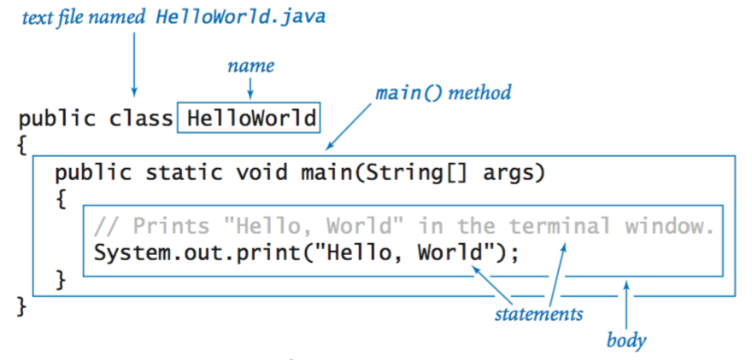

Editing, compiling, and executing.

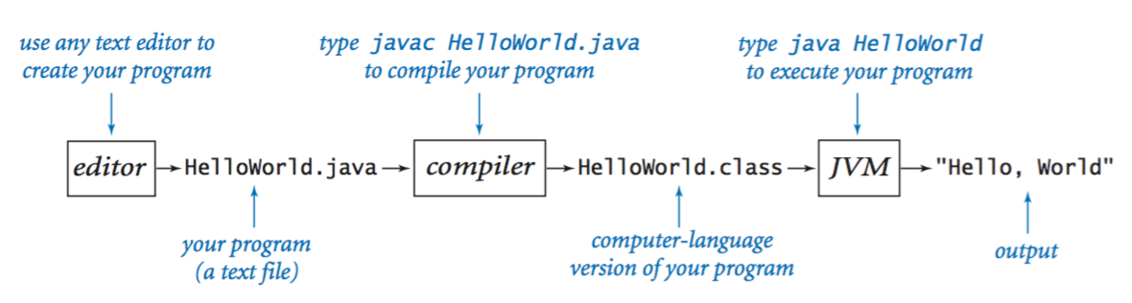

Built-in data types.

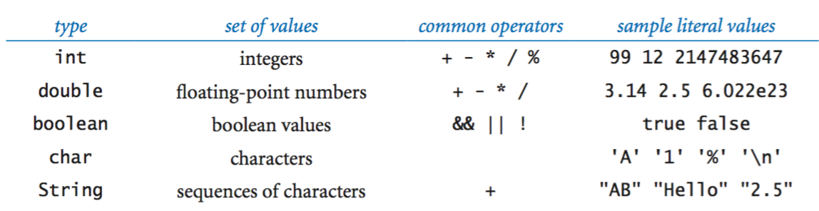

Declaration and assignment statements.

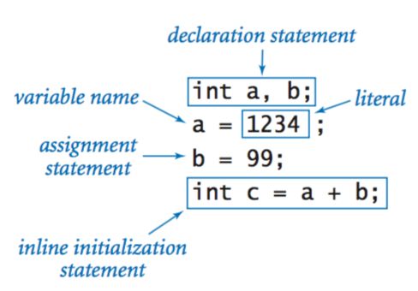

Integers.

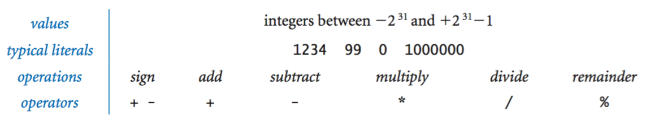

Floating-point numbers.

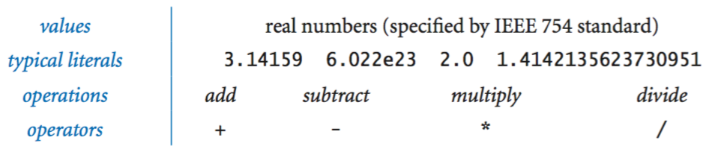

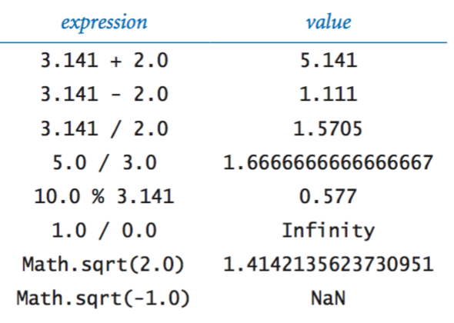

Booleans.

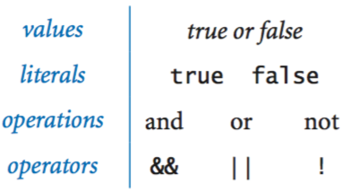

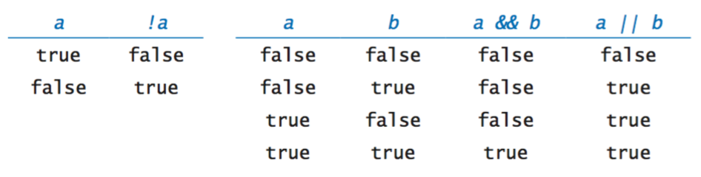

Comparison operators.

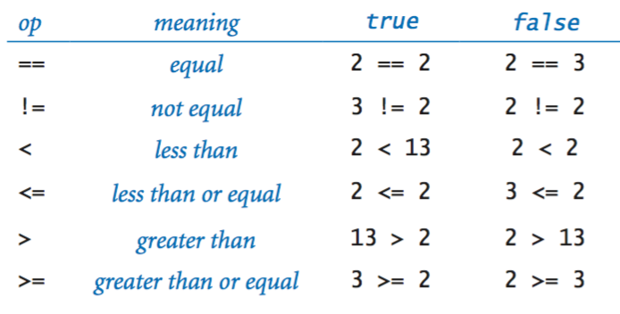

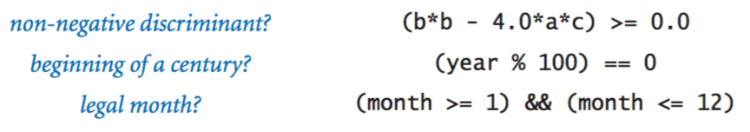

Printing.

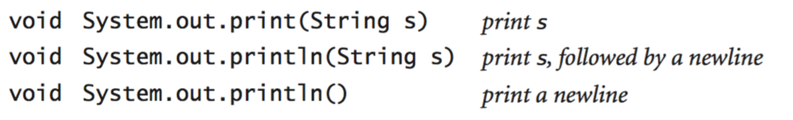

Parsing command-line arguments.

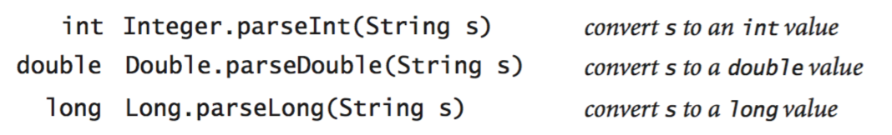

Math library.

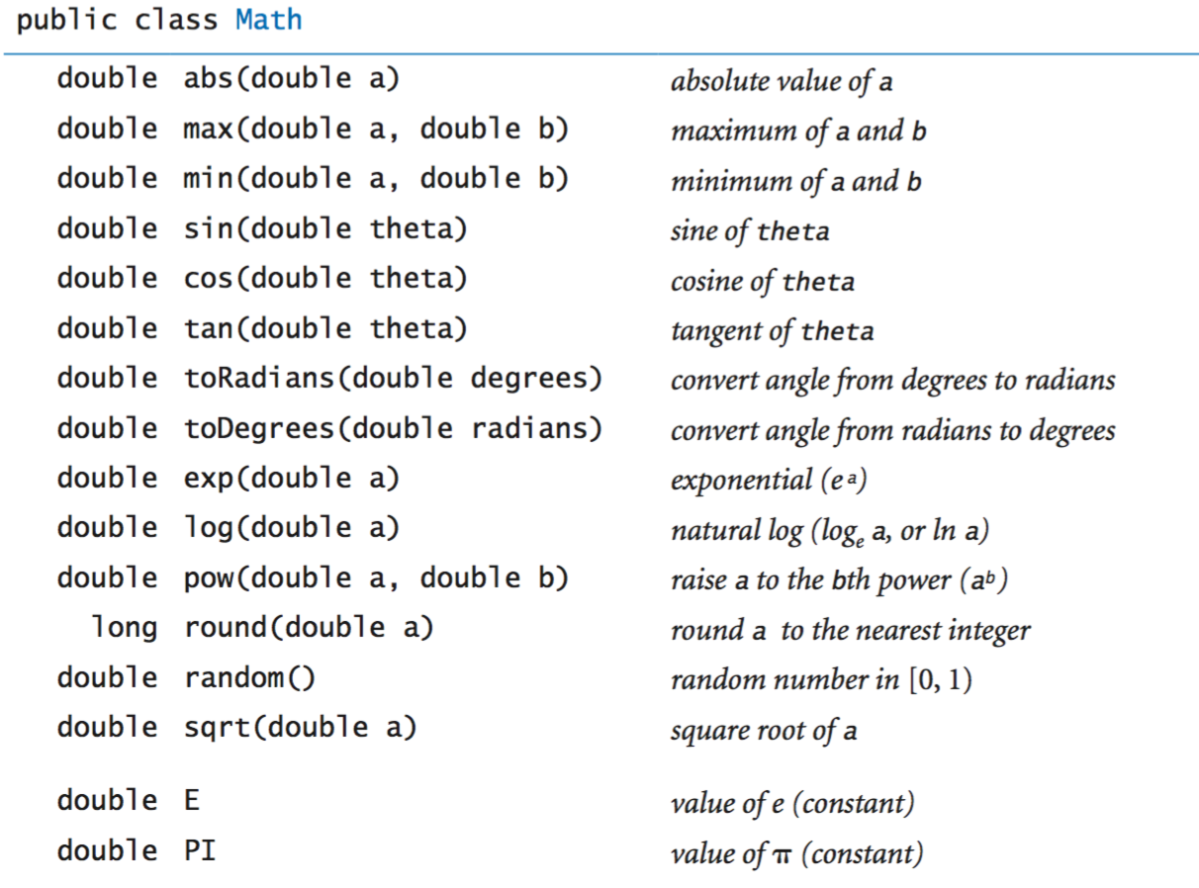

The full [java.lang.Math API](http://docs.oracle.com/javase/8/docs/api/java/lang/Math.html).

Java library calls.

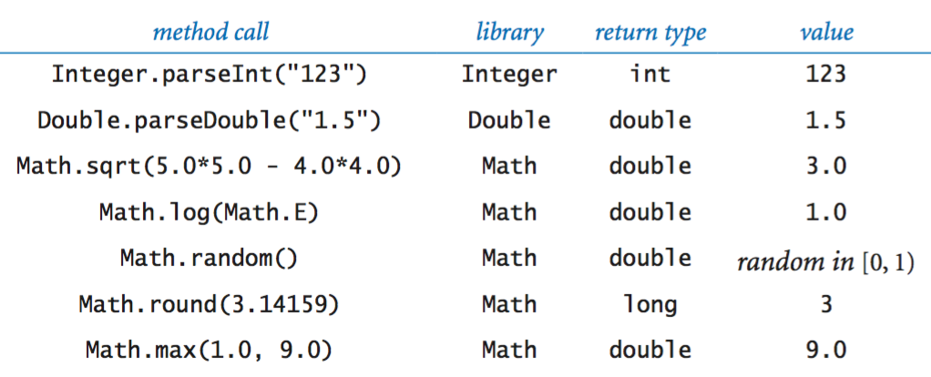

Type conversion.

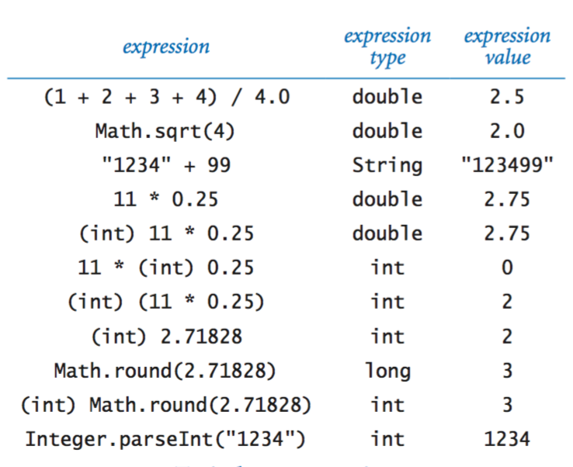

Anatomy of an if statement.

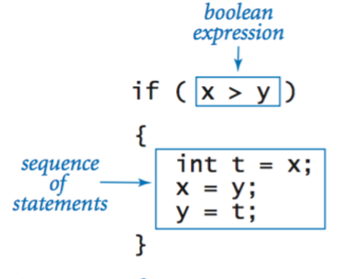

If and if-else statements.

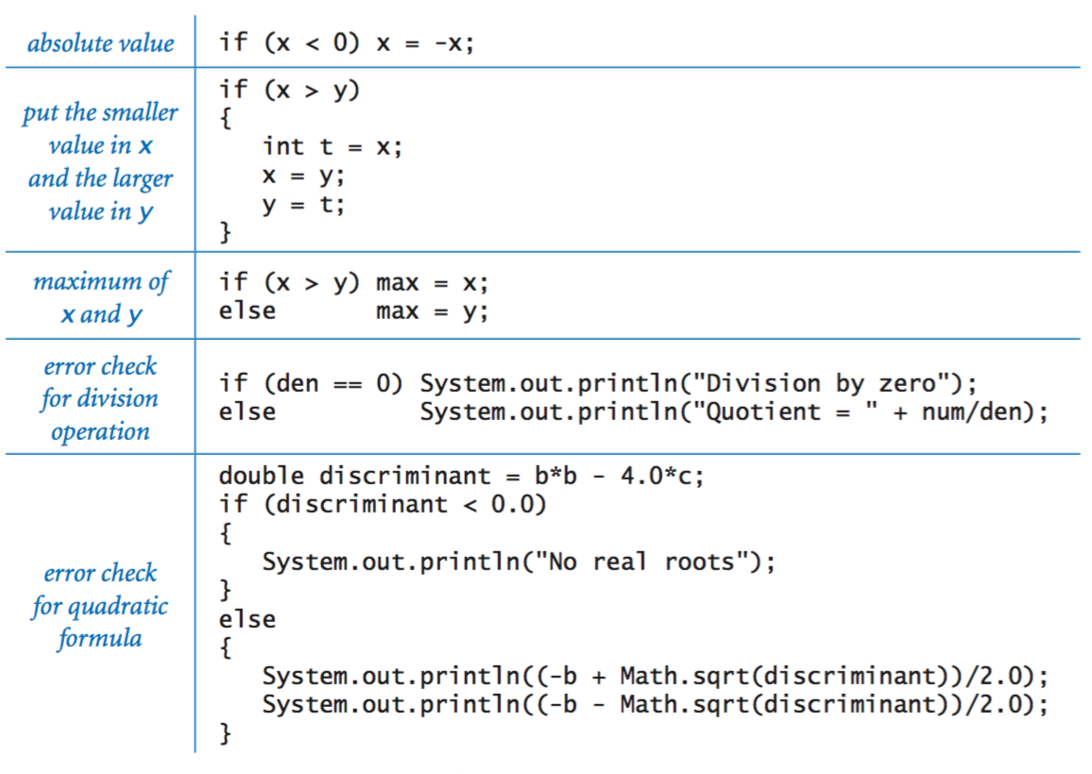

Nested if-else statement.

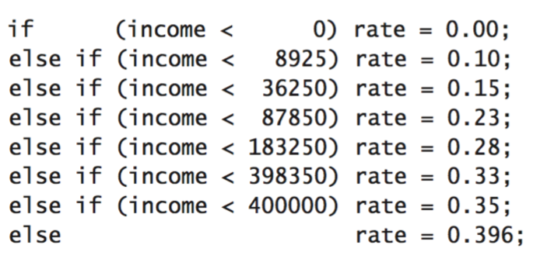

Anatomy of a while loop.

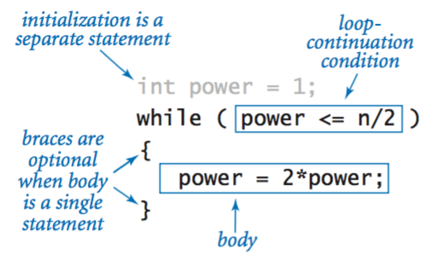

Anatomy of a for loop.

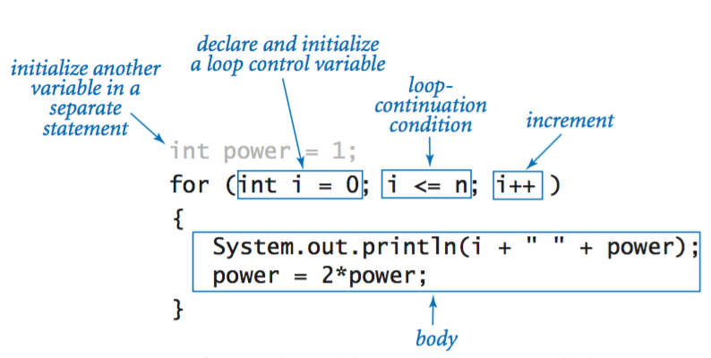

Loops.

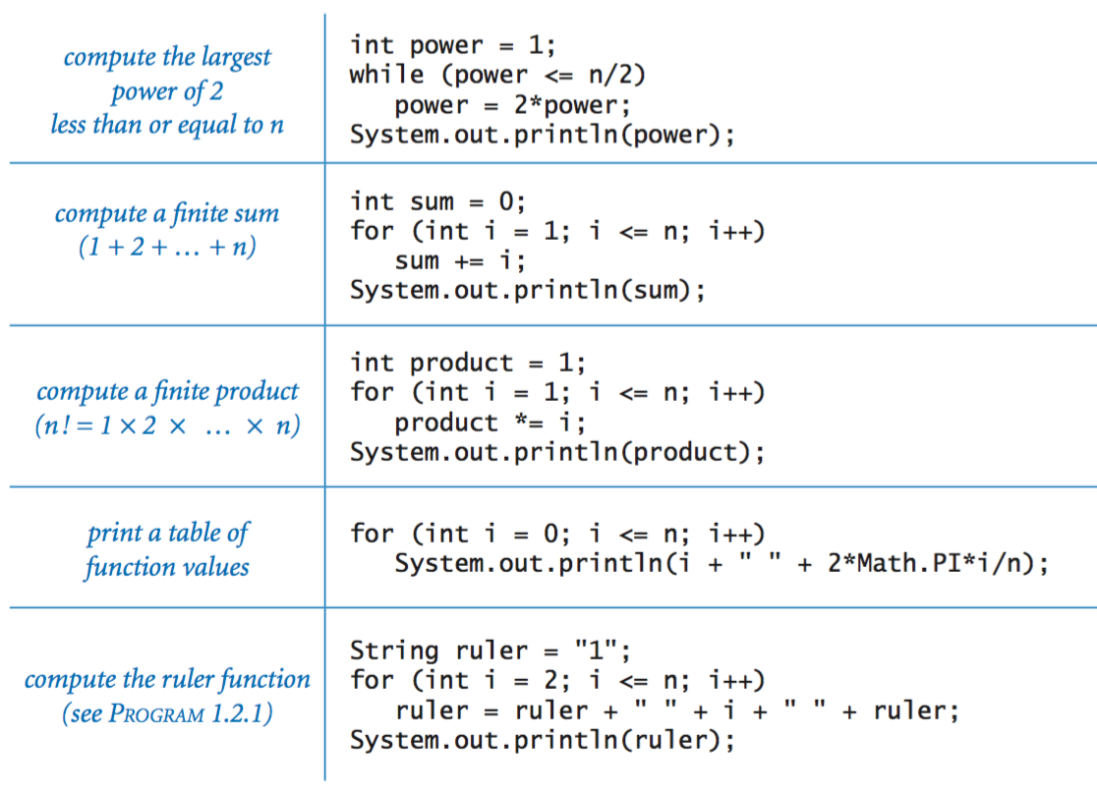

Break statement.

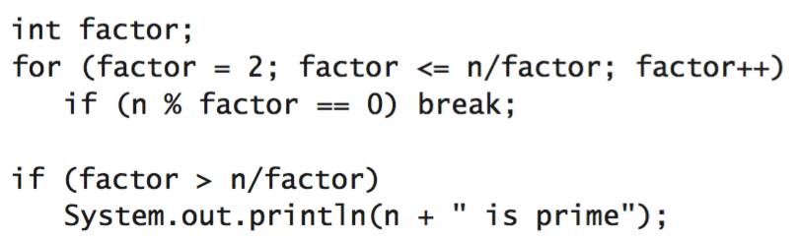

Do-while loop.

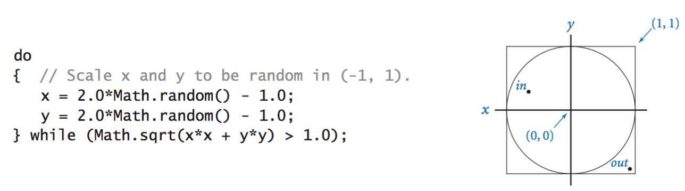

Switch statement.

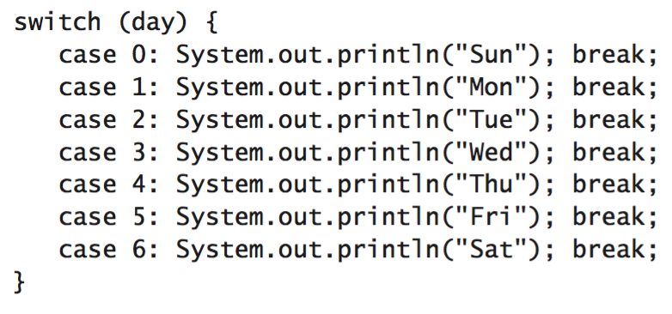

Arrays.

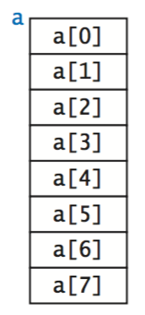

Inline array initialisation.

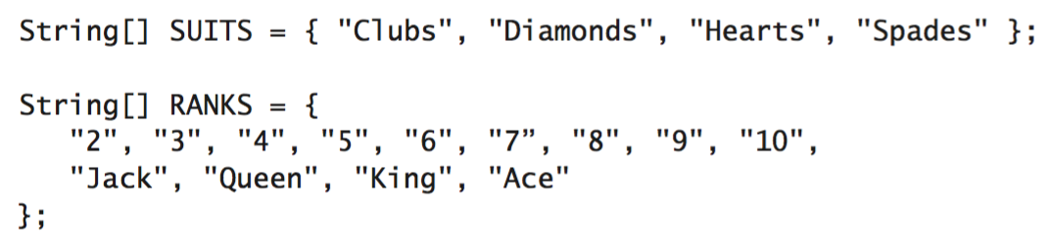

Typical array-processing code.

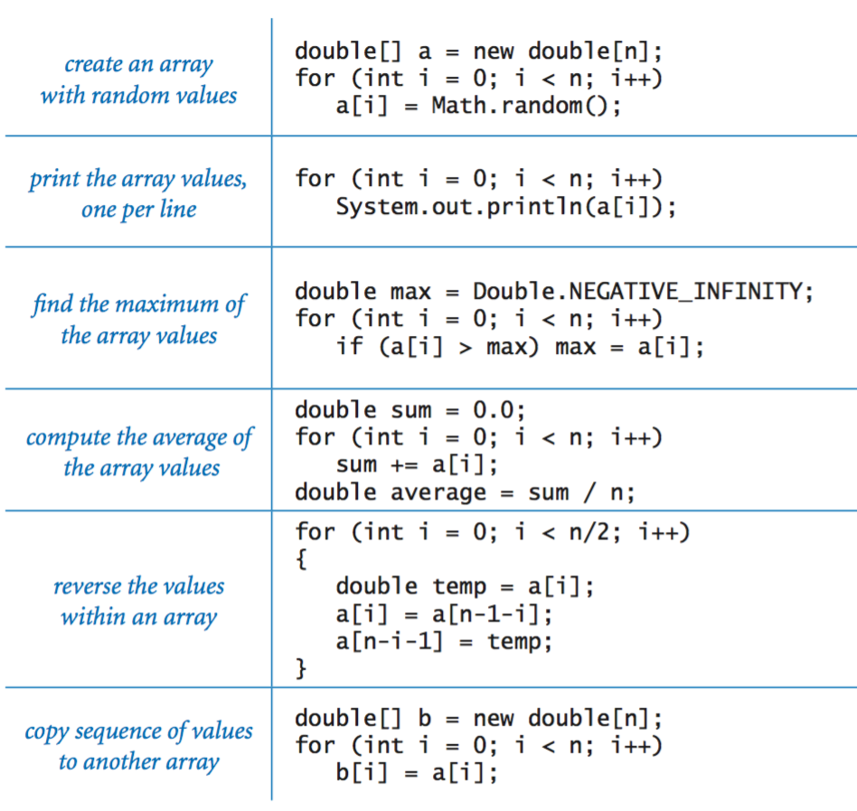

Two-dimensional arrays.

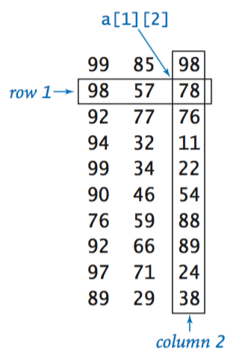

Inline initialization.

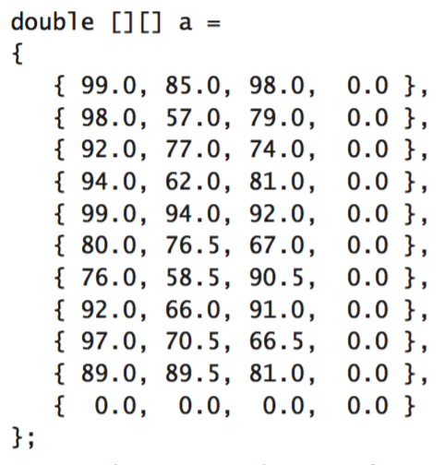

Our standard output library.

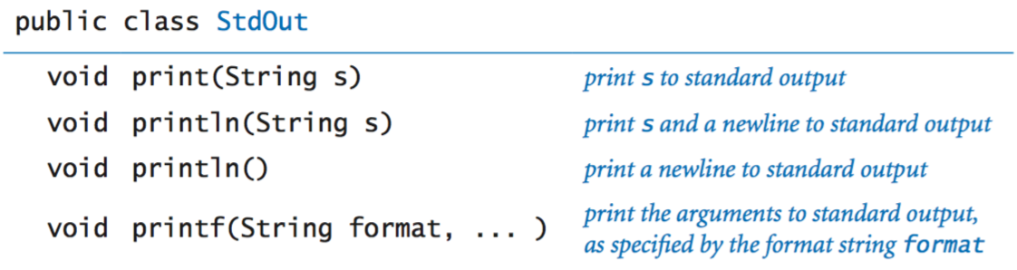

The full [StdOut API](https://introcs.cs.princeton.edu/java/stdlib/javadoc/StdOut.html).

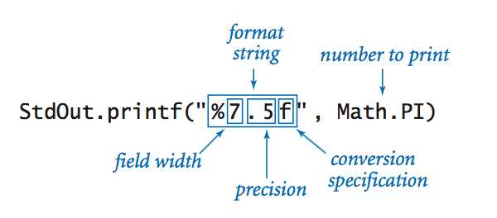

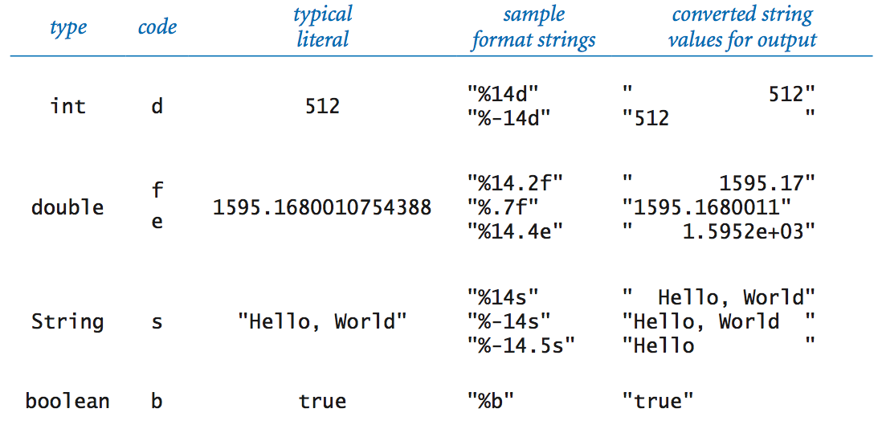

Our standard input library.

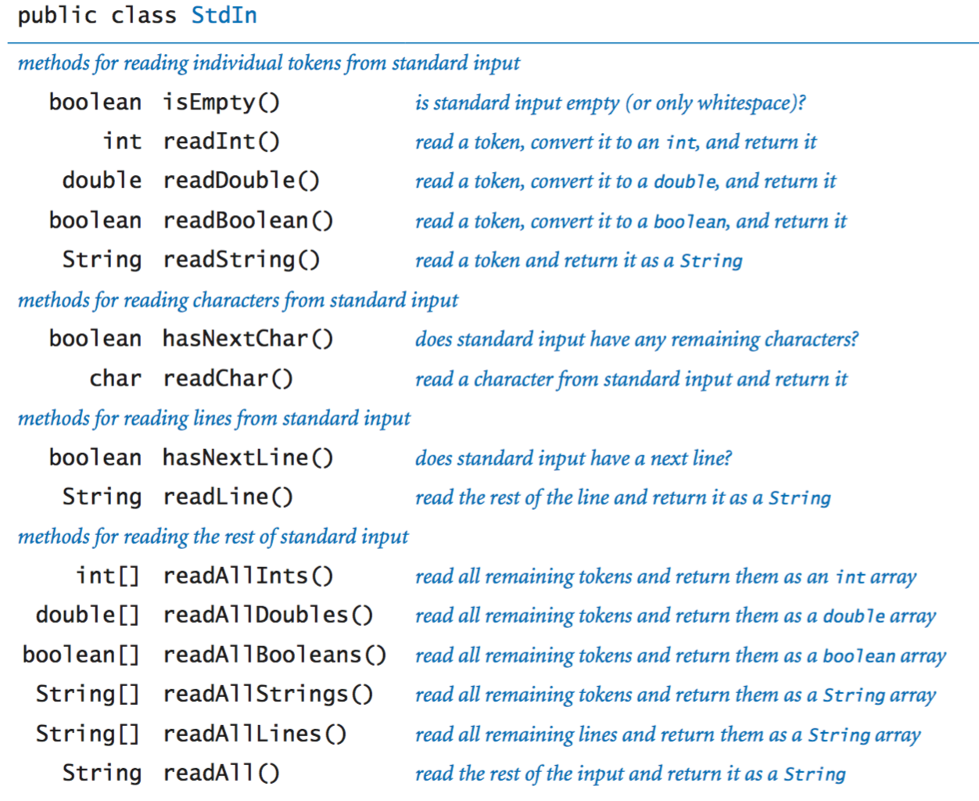

The full [StdIn API](https://introcs.cs.princeton.edu/java/stdlib/javadoc/StdIn.html).

Our standard drawing library.

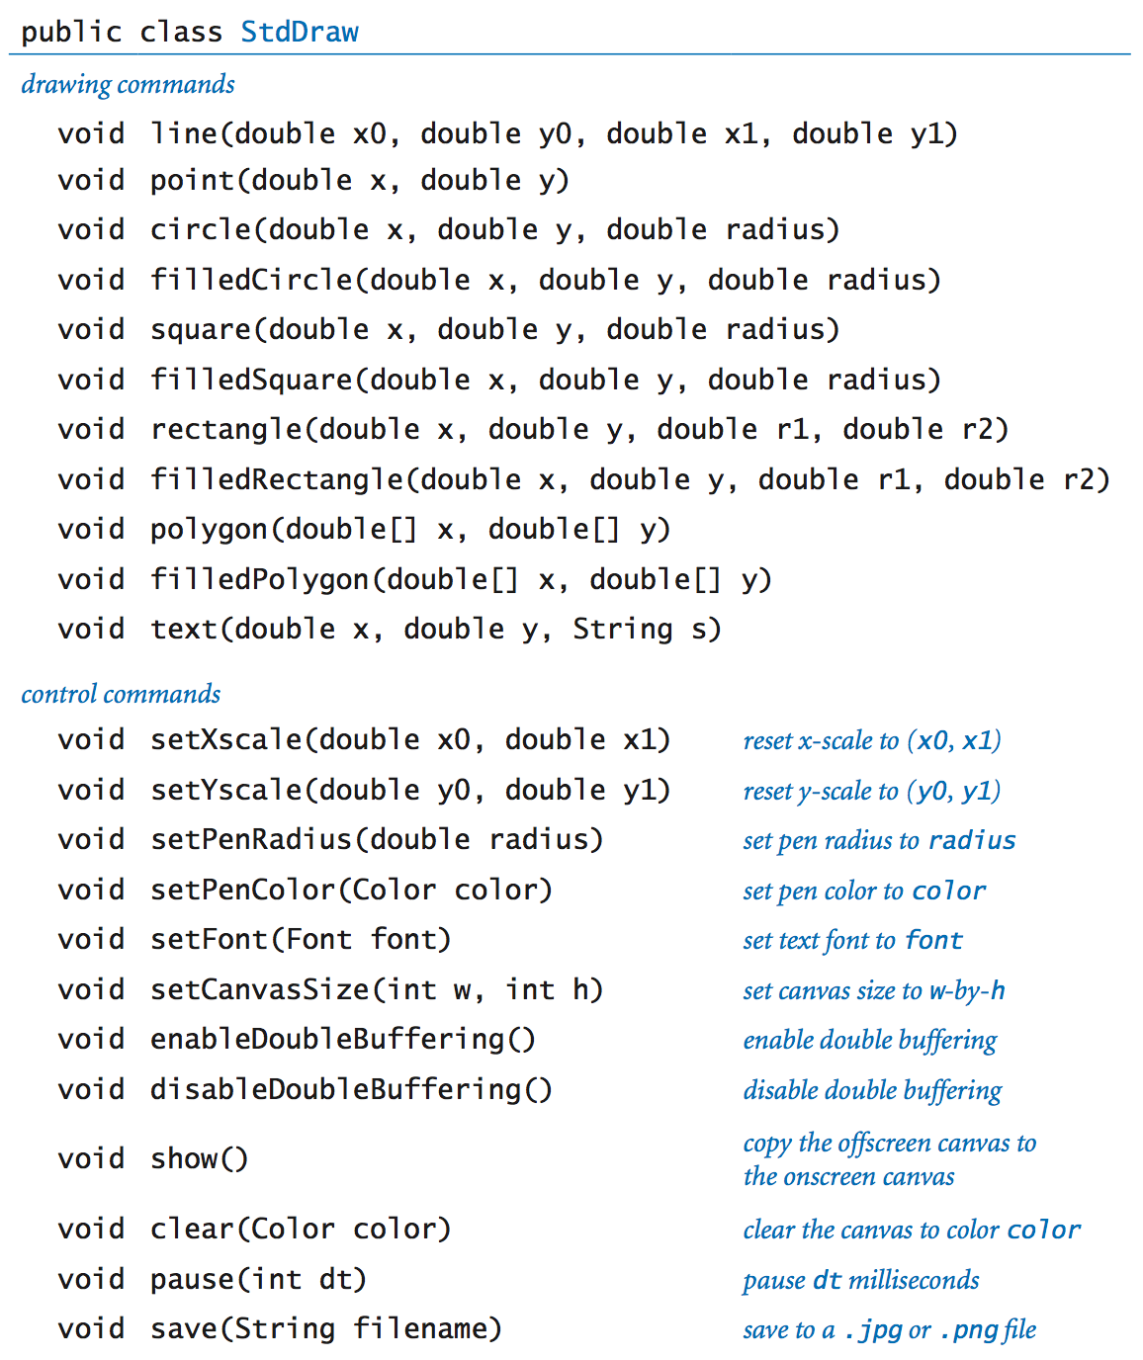

The full [StdDraw API](https://introcs.cs.princeton.edu/java/stdlib/javadoc/StdDraw.html).

Our standard audio library.

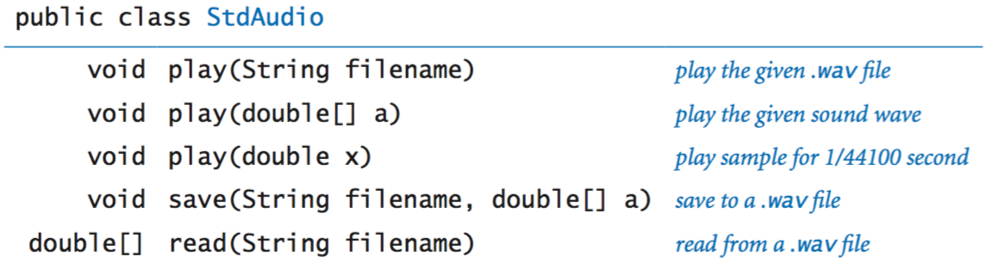

The full [StdAudio API](https://introcs.cs.princeton.edu/java/stdlib/javadoc/StdAudio.html).

Command line.

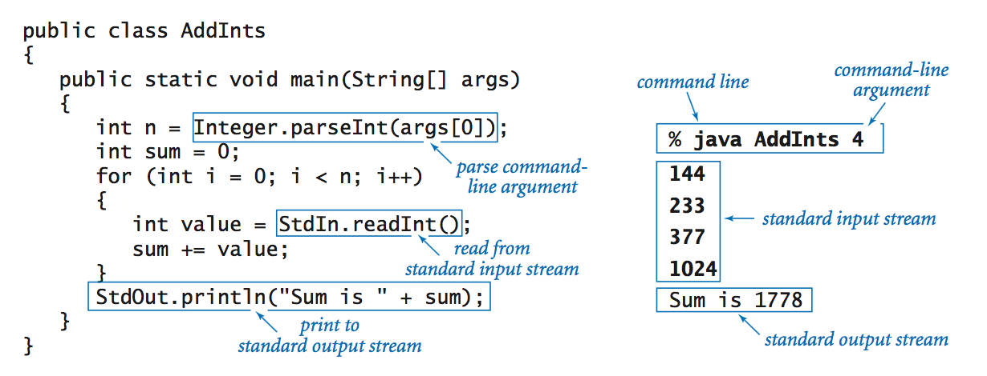

Redirection and piping.

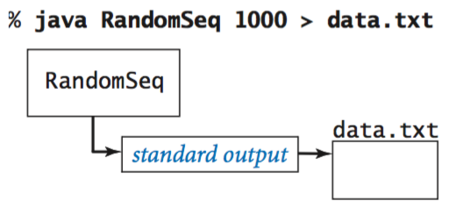                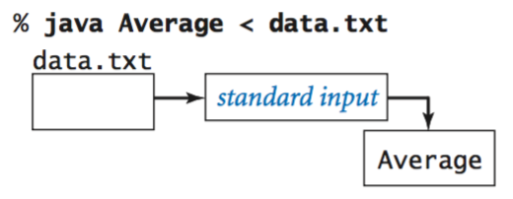

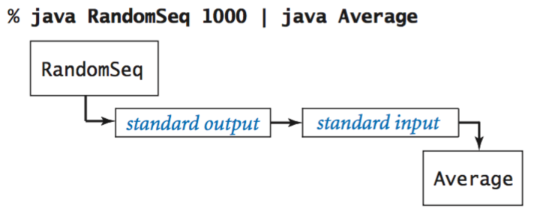

Functions.

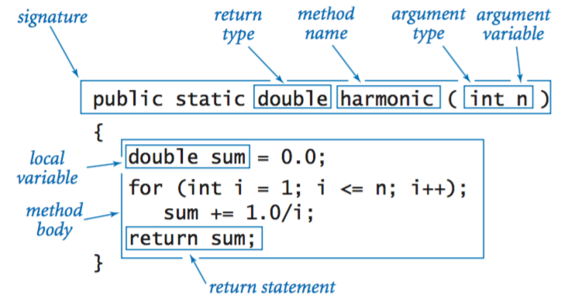

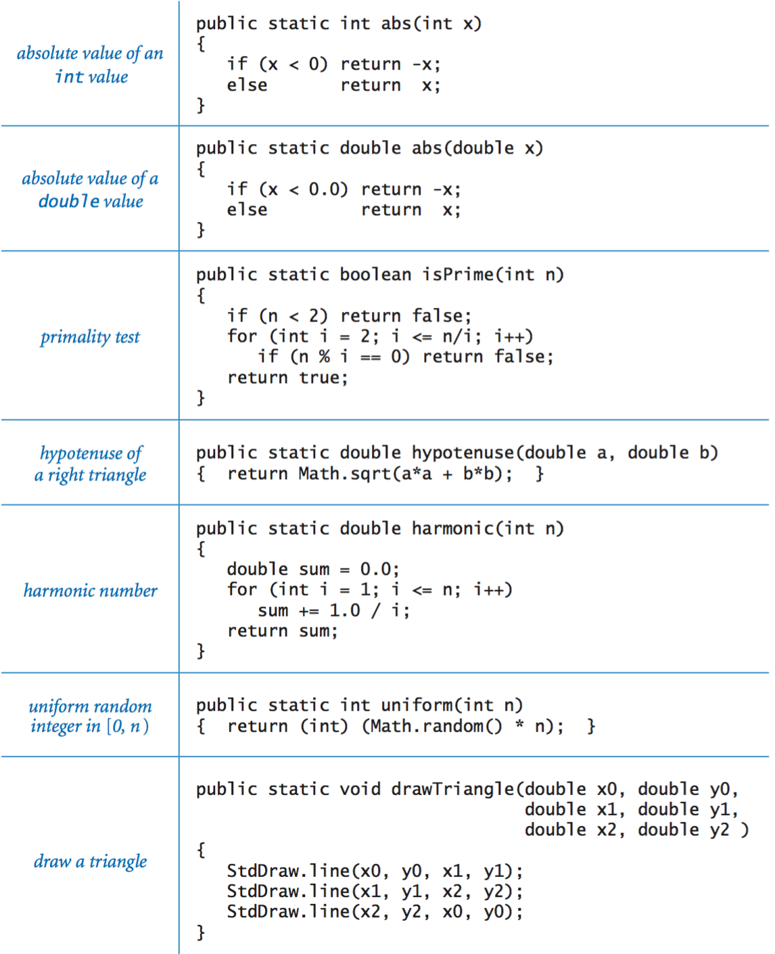

Libraries of functions.

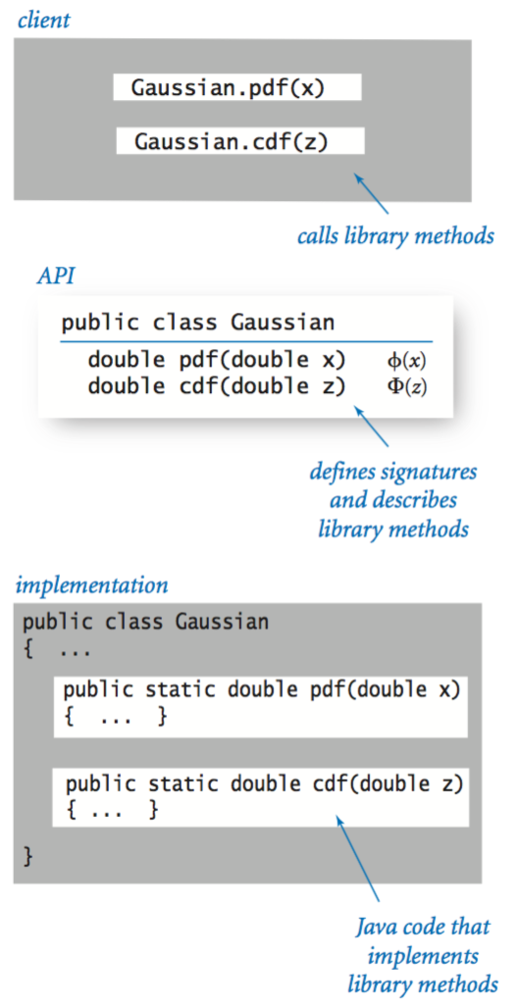

Our standard random library.

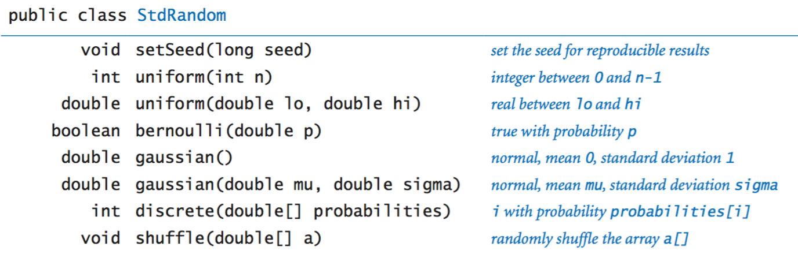

Our standard statistics library.

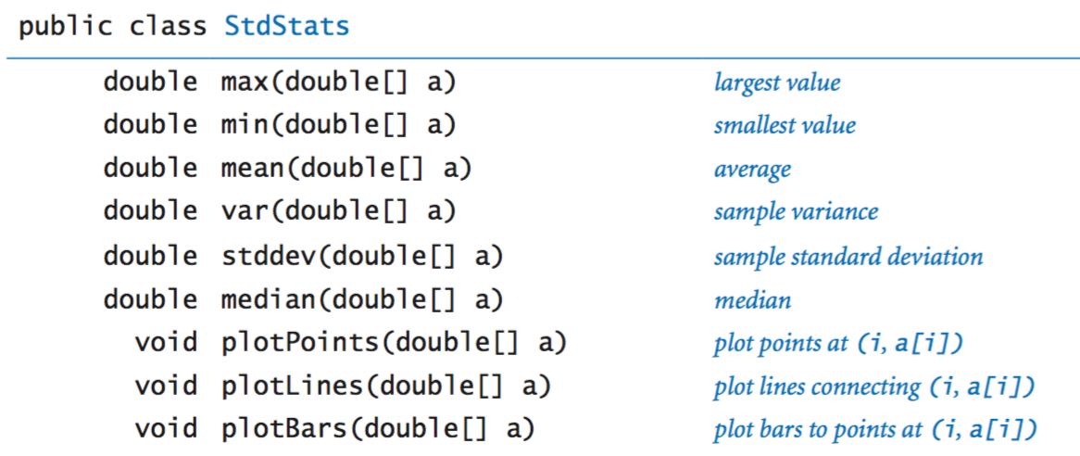

Using an object.

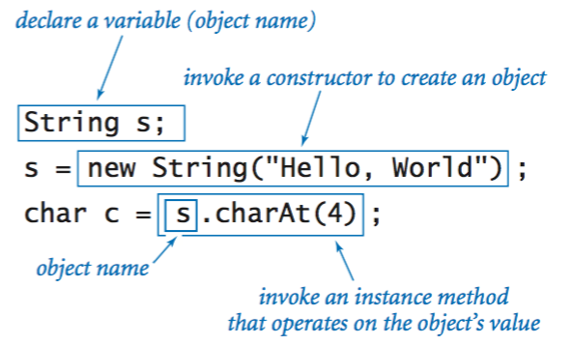

Instance variables.

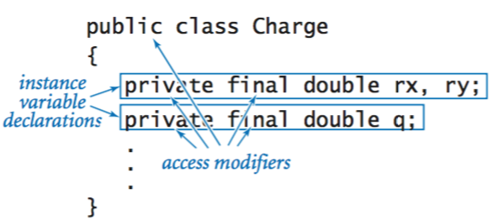

Constructors.

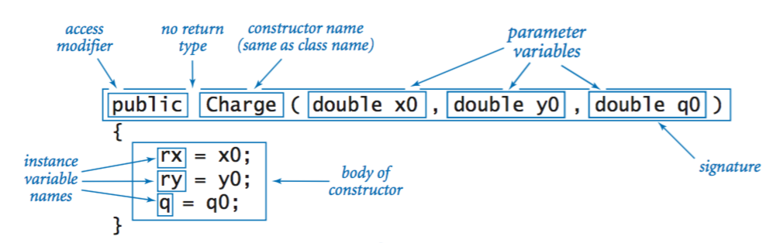

Instance methods.

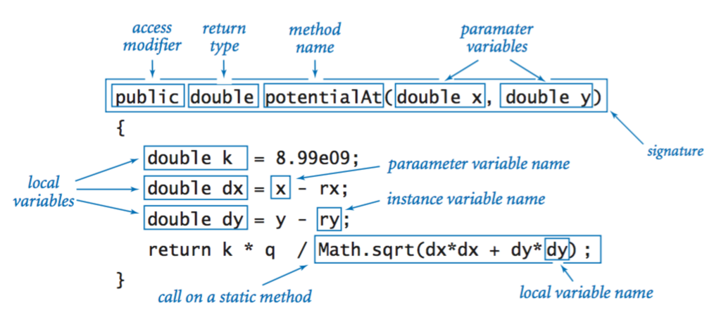

Classes.

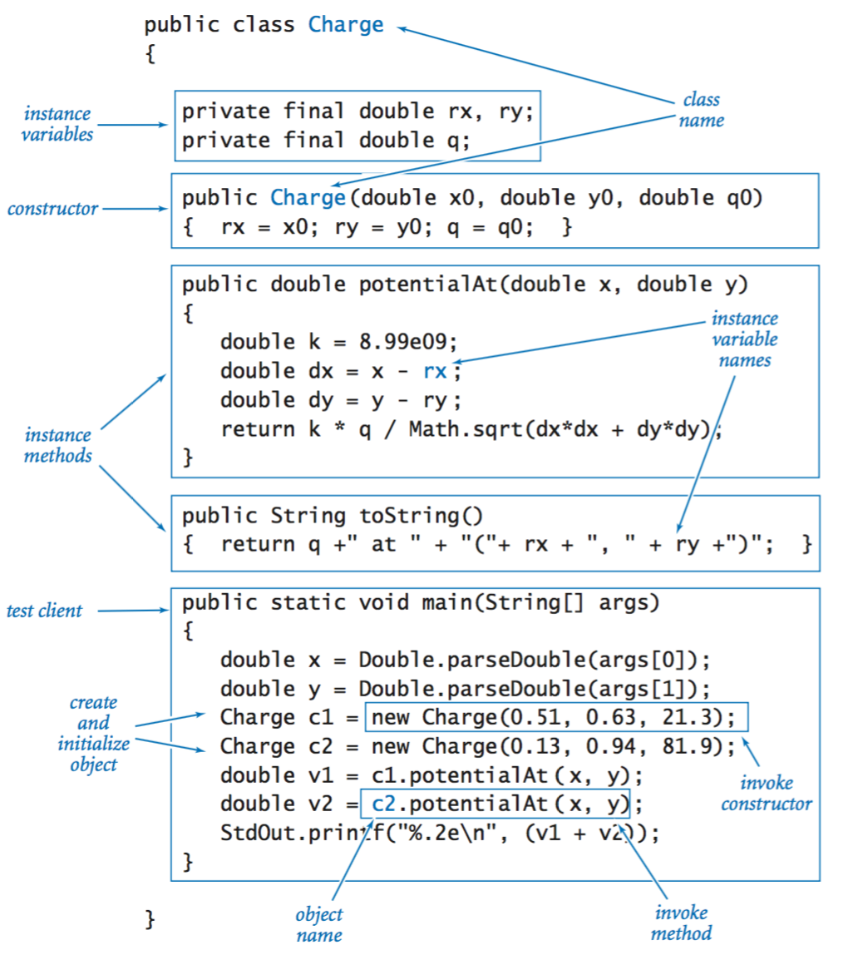

Object-oriented libraries.

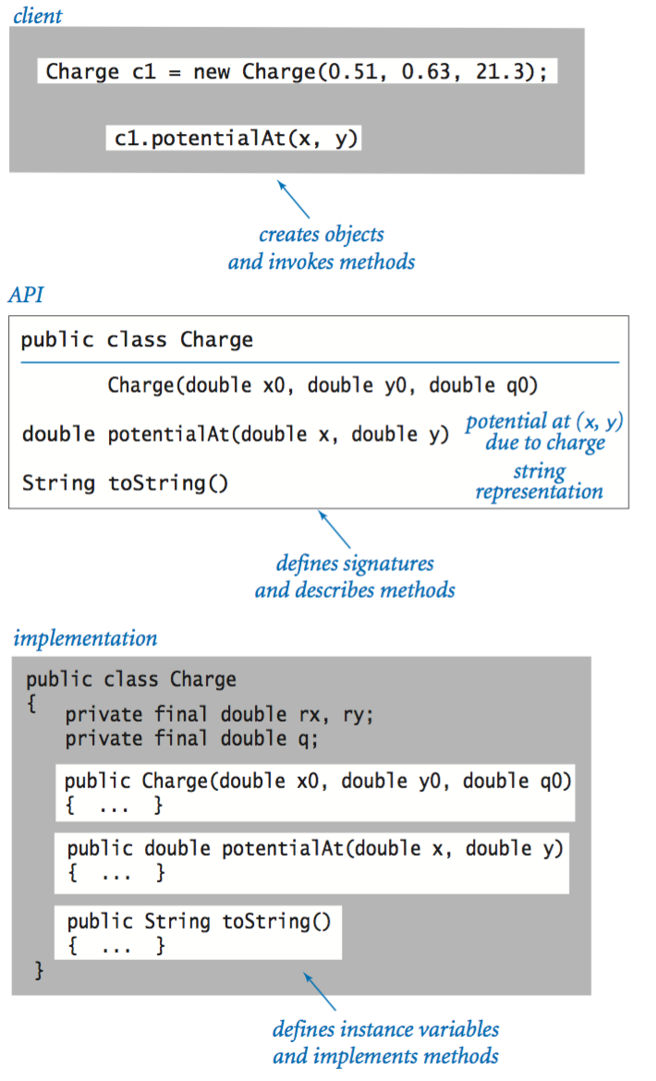

Java's String data type.

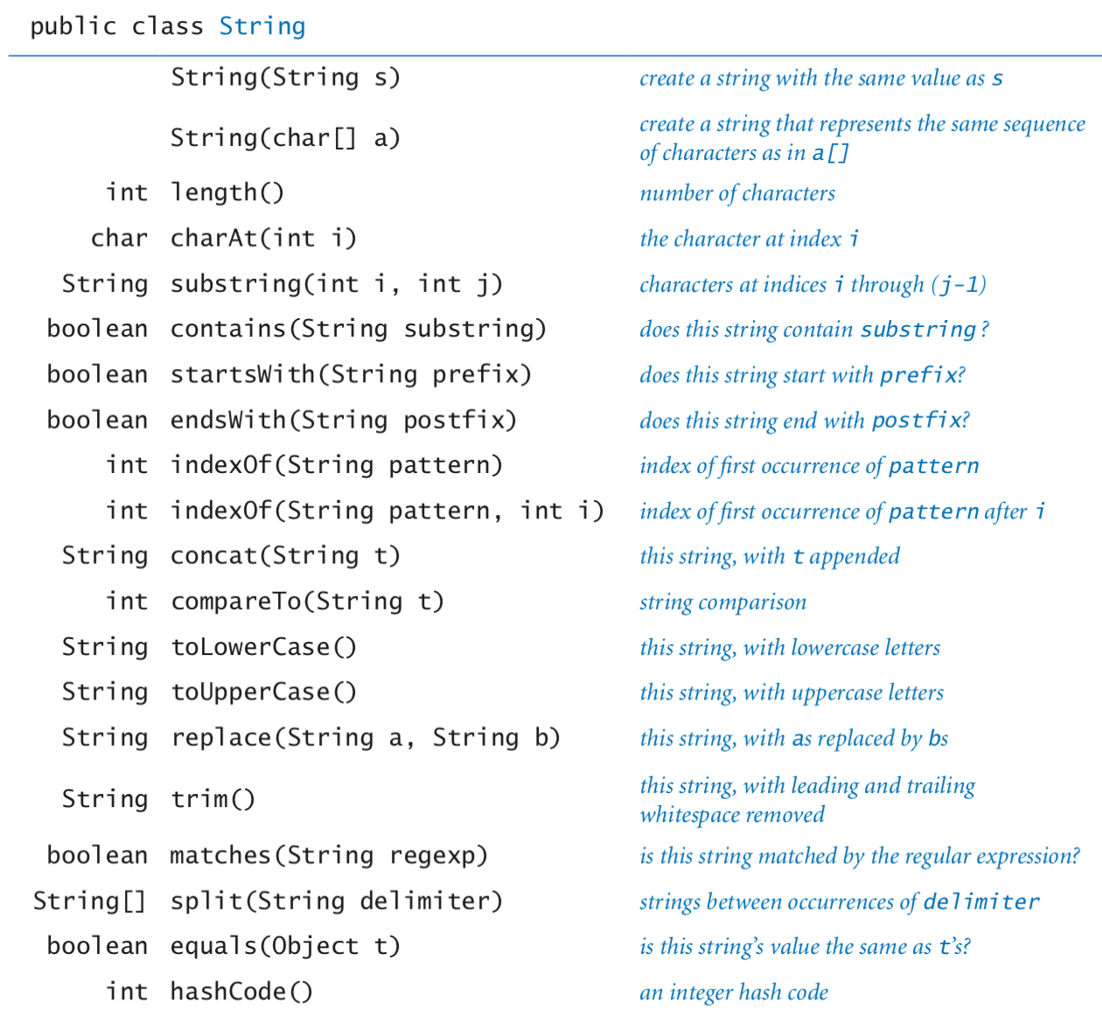

The full [java.lang.String API](http://docs.oracle.com/javase/6/docs/api/java/lang/String.html).

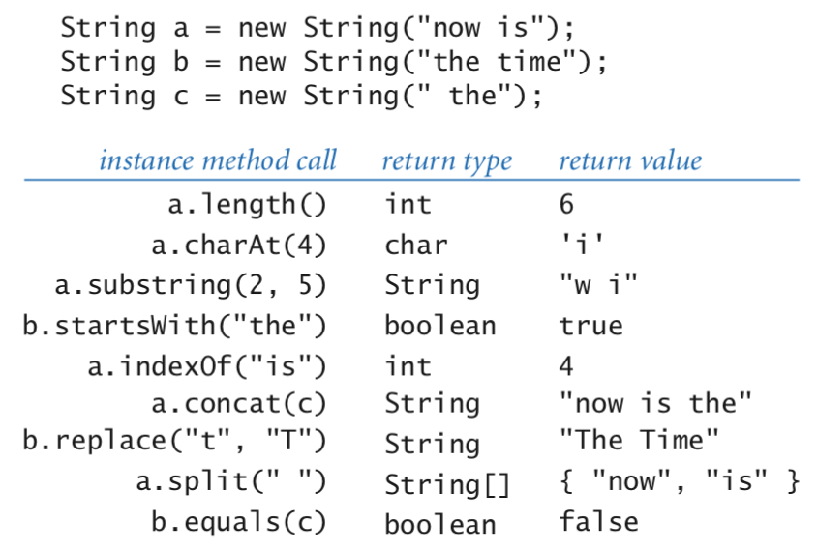

Java's Color data type.

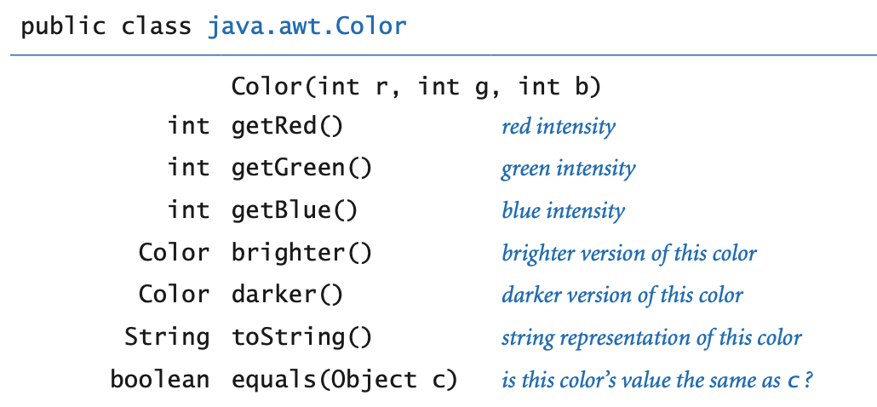

The full [java.awt.Color API](http://docs.oracle.com/javase/6/docs/api/java/awt/Color.html).

Our input library.

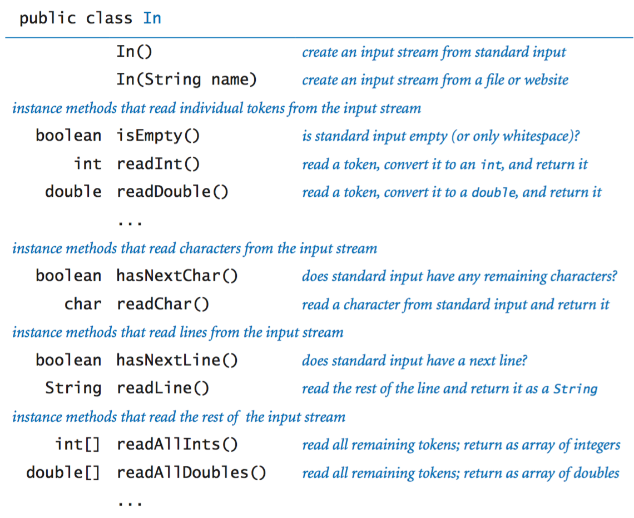

The full [In API](https://introcs.cs.princeton.edu/java/stdlib/javadoc/In.html).

Our output library.

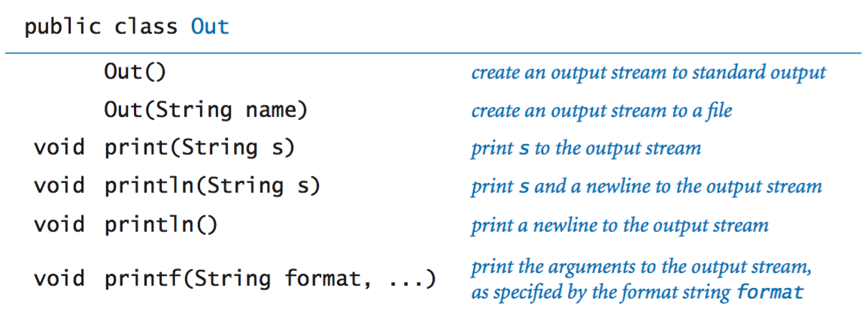

The full [Out API](https://introcs.cs.princeton.edu/java/stdlib/javadoc/Out.html).

Our picture library.

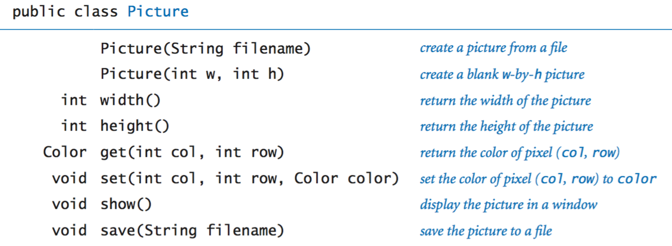

The full [Picture API](https://introcs.cs.princeton.edu/java/stdlib/javadoc/Picture.html).

Our stack data type.

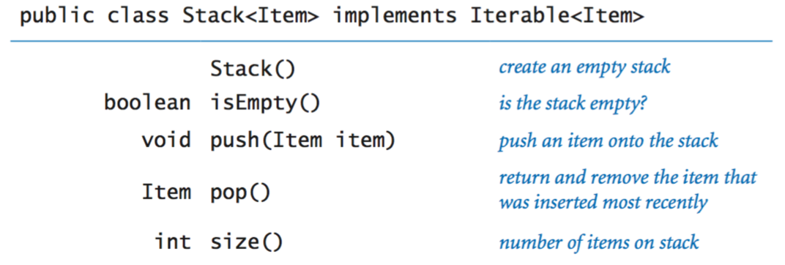

The full [Stack API](https://introcs.cs.princeton.edu/java/code/javadoc/Stack.html).

Our queue data type.

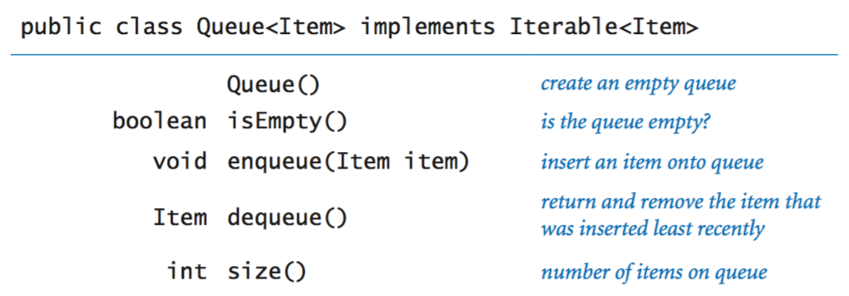

The full [Queue API](https://introcs.cs.princeton.edu/java/code/javadoc/Queue.html).

Iterable.

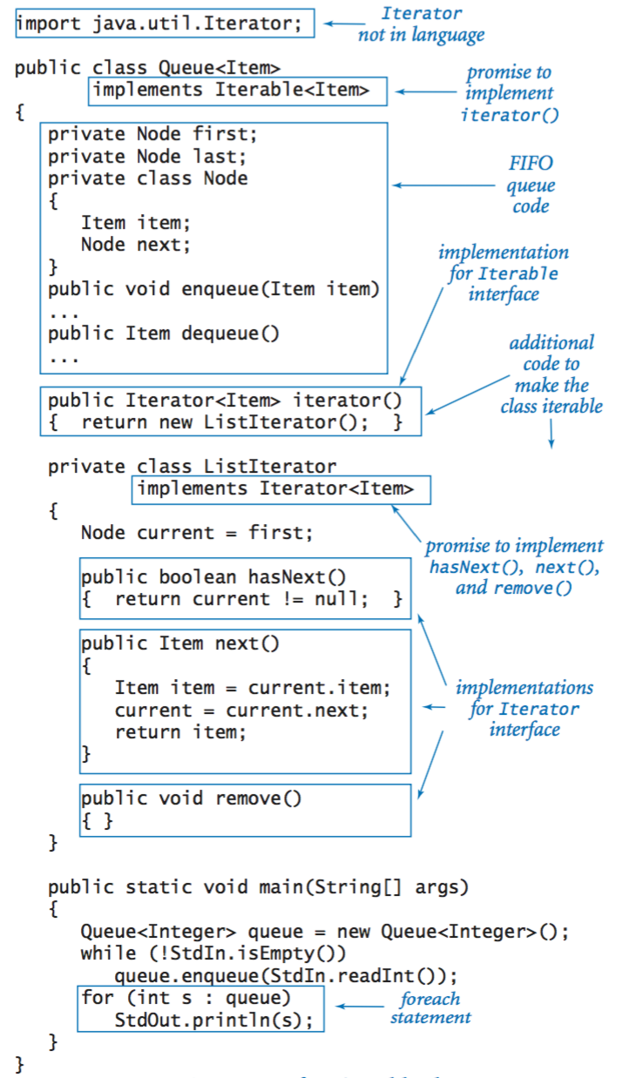

Our symbol table data type.

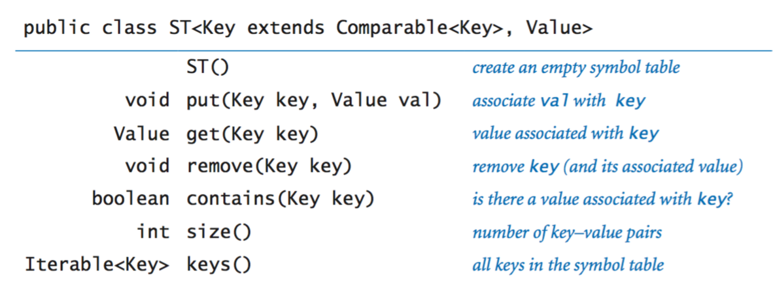

The full [ST API](https://introcs.cs.princeton.edu/java/code/javadoc/ST.html).

Our set data type.

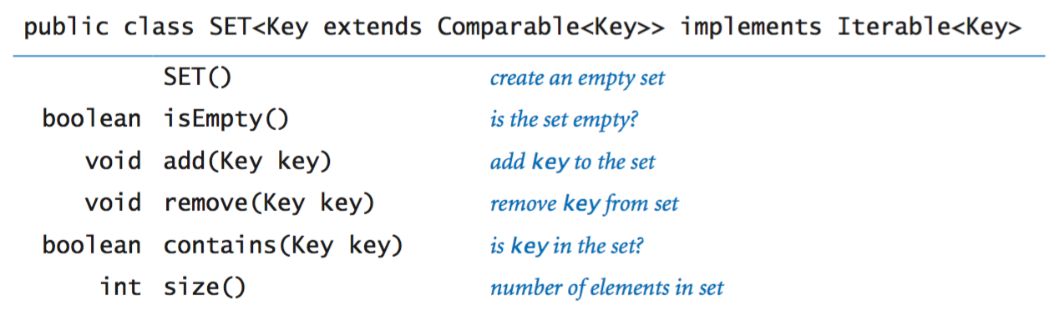

The full [SET API](https://introcs.cs.princeton.edu/java/code/javadoc/SET.html).

Our graph data type.

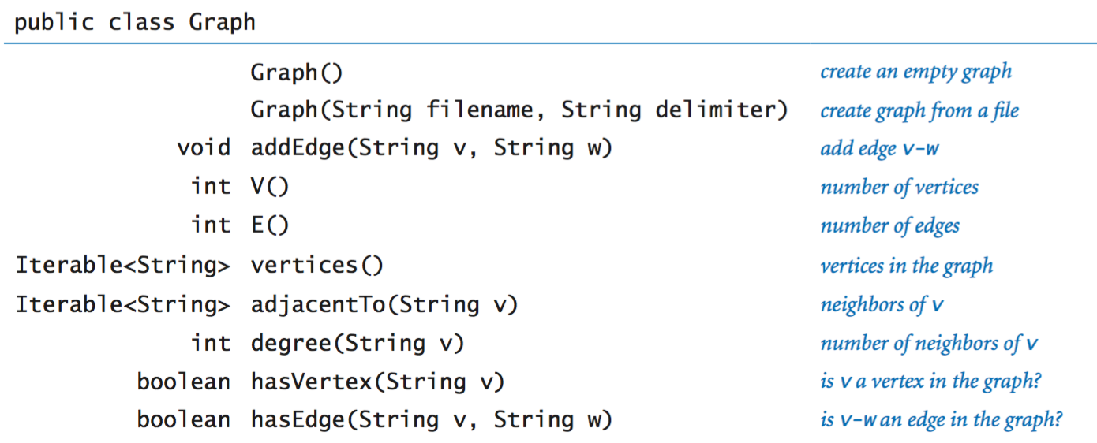

The full [Graph API](https://introcs.cs.princeton.edu/java/code/javadoc/Graph.html).

Compile-time and run-time errors. Here's a [list of errors](https://introcs.cs.princeton.edu/java/11cheatsheet/errors.pdf). It includes a list of common error message and typical mistakes that give rise to them.